AVA An Automated Voice Activated Advisement System

(User Manual)

By: The Software Gurus

Team Members:

Omar Obidat

Jesse Parron

Allen Asencio

Dan Ferdetta

Sumit Mistry

Software Engineering 515

Fall 2022

Professor Johnson

December 19, 2022

Table of Contents

1. Introduction…………………………………………………………………………………. 1

2. Purpose of the System………………………………………………………………………. 1

3. Project Goals …………………………………………………………………………………2

4. Purpose of the Current Document (Manual) …………………………………………………2

5. User’s Manual ………………………………………………………………………………...2

5.1. Steps to launch the System ………………………………………………………………2

5.2. Steps to Navigate the System ……………………………………………………………4

6. FAQ…………………………………………………………………………………………...8

7. Glossary ………………………………………………………………………………………8

# Introduction

The automated voice advisement system (AVA), a tool built exclusively for Montclair State University will allow students in the undergraduate class of the computer science department to sign on to the system and vocally request assistance for academic advice.

This document contains the sets of instructions for the users on how to launch and use the system. This manual is developed in such a way that the user can navigate and get help from the self-contained instructions of the system by finding the keyword from the glossary or the table of contents.

The system is exclusively built and accessible for the Montclair State University students and has functionalities that a user can utilize by verbally instantiating the module. Users can access those primary functions listed in the User’s Manual section. Once done, the user can log out of the system.

# Purpose of the System

Automated Voice Activated Advisement System (AVA) is a web-app based voice activated system that facilitates student advisement vocally in an efficient and accurate manner. It can aid in choosing courses that count toward the student’s major that they will be able to take. It helps to prevent the student’s accidental selection of wrong course choice, a course taken which is not needed to graduate. Ultimately the reduction of the in-person workload on the academic advisor and the system provides the cost-effective solution in the long run.

The system allows a user to verbally communicate with an automated adviser, which guides them through the process of picking the correct course(s) to ensure the student knows which courses they must enroll in, the user can view all the available courses for the term, filter the courses of interest, view course catalog for the program, view specific course information, view own GPA and Transcript, and access the GPA calculator. All these primary functions will deliver users the basic and essential information for their needs. Once done, they can log out of the system

# Project Goals

An Automated Voice Activated Advisement System (AVA) is a tool that will provide the efficient technology to the Montclair State University. This project will save time and cost for the institution such that it doesn't take too many labor hours advising students in picking courses that count toward the student’s major that they will be able to take. The manual labor work is reduced significantly and ultimately the sponsors save the time and cost associated with face to face advice to the students.

# Purpose of the Current Document (Manual)

The purpose of this document is to allow a student or user to understand the layout of the document and how to find the functions they want to utilize.

This manual covers the below functions on how to use them after successfully passing the authentication.

Manual covers the below use cases:

* 1. How can a user view all the available courses for the term?
  2. How can a user filter the courses of interest?
  3. How to view the course catalog for the program?
  4. How to view specific course information?
  5. How to check a user's own GPA and Transcript?
  6. How and where to calculate the GPA?

# User’s Manual

## Steps to launch the System

* + 1. The system is executable and called by accessing the CD that contains the exe folder, going into the dist folder, entering the Database folder, scrolling down and launching the executable named Database.

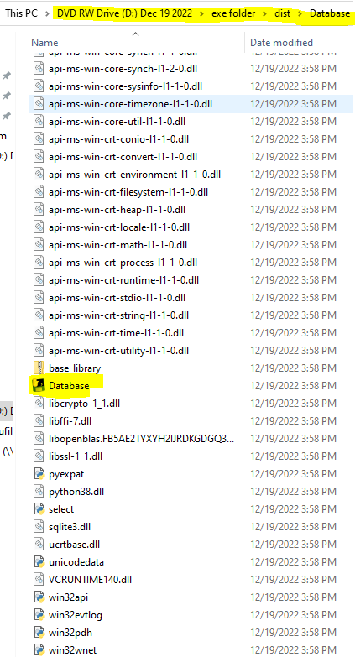

* + 1. Once opened, the mandatory sign in page will allow users to sign in using their active Montclair State University MSU-CWID and password to enter the system. This sign-in module will be connected to the school’s database with information of students recorded within.

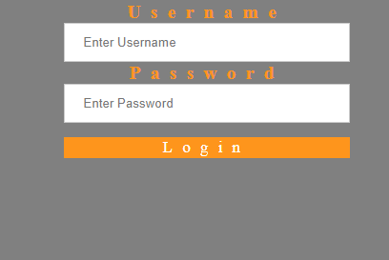

Figure 1: This is what the Log-In screen looks like

## Steps to Navigate the System

Below are the steps on how to navigate the system:

* + 1. Once successfully authenticated, the user is redirected to the below Dashboard. The home screen that connects with each module. Dashboard screen which user can vocally access any module.

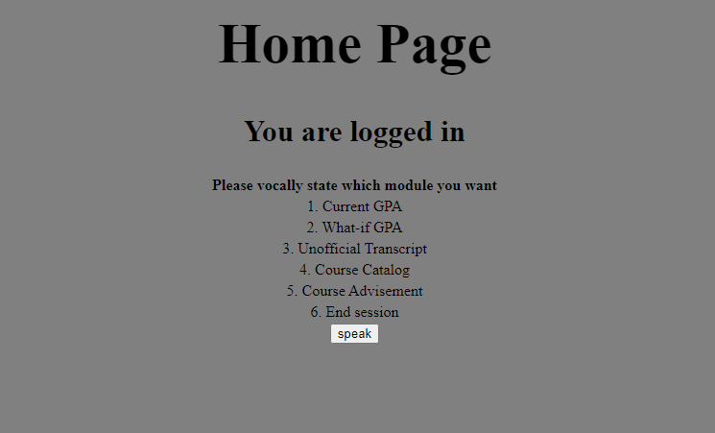

Figure 2: This is what the home screen looks like after a successful login

* + 1. Upon clicking the “speak” button, the user may say something along the lines of “Current GPA”. The user can access the GPA module allowing the student to view their current GPA. The user can then click the “speak” button, say “home”, then they will be redirected to the home screen.

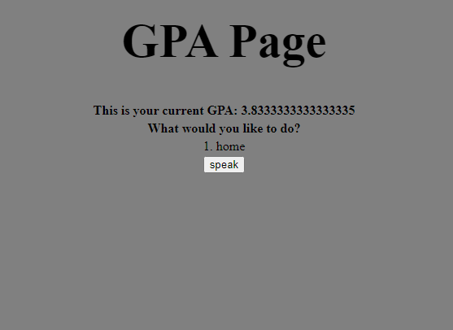

Figure 3 : This is the “Current GPA” screen

* + 1. From the home screen, upon clicking the “speak” button, the user may say something along the lines of “What-If GPA”. The user can access the What-If GPA module allowing the student to view their current GPA. The user can then click the “speak” button, say a whole number to indicate how many classes they would like to add to their “what-if gpa” calculation, followed by the grade points of each class, then the user will be redirected to the screen listed in Figure 4. The user can then click the “speak” button, say “home”, then they will be redirected to the home screen.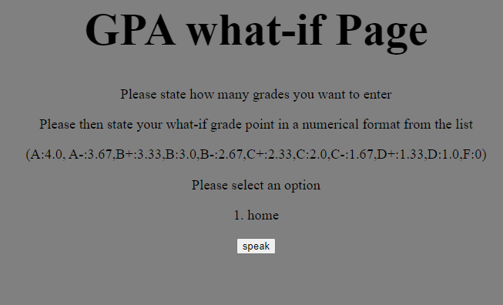

Figure 4 : This is the “What-If GPA” screen

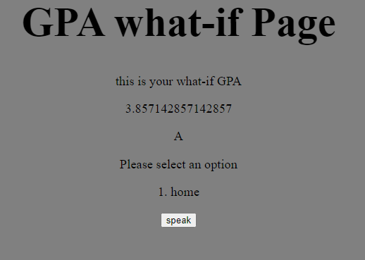

Figure 5 : This is the “Calculated What-If GPA” screen

* + 1. From the home page the user can click the “speak” button and the user can request the “Transcript module” to access their current transcript. After the Transcript is displayed, the user can then click the “speak” button and go back to the home page.

Screen-image-6: The students transcript module (below)

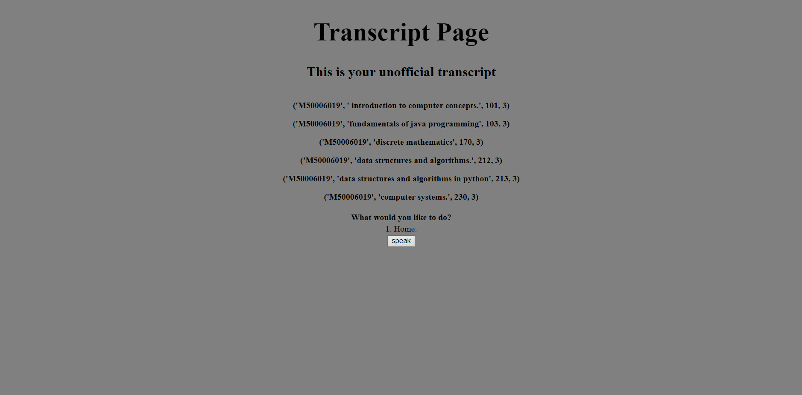

Figure 6 : This is the “Unofficial Transcript” screen

5.2.4. From the home page, the user can click the “speak” button and request “catalog”. This

will take them to the course catalog page where they can see all the courses available to take. From this page the user can click the “Speak” button again, requesting to either go back to the homepage by verbally stating “home”, or they can view information on the course by verbally stating “information on course x” x being the course they wish to read more information on. Afterwards, the user can then repeat that action, or request to go home.

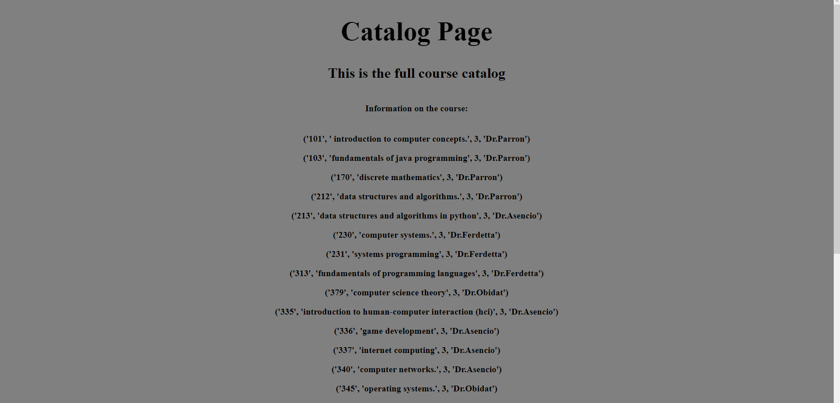

Figure 7 : This is the top of the “Course Catalog” screen

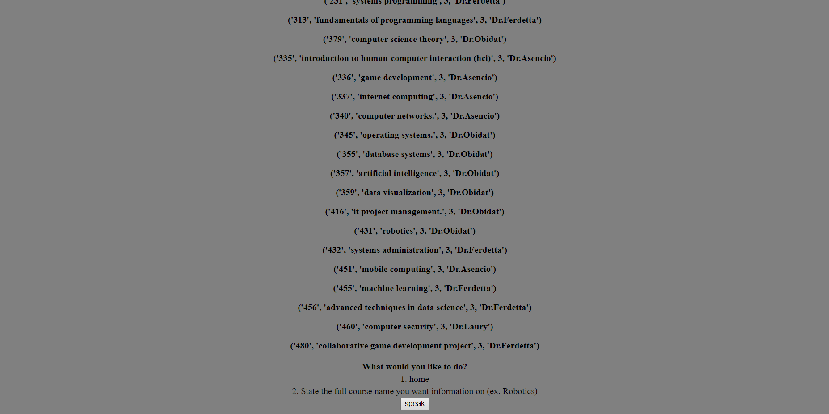

Figure 8 : This is the bottom of the “Course Catalog” screen

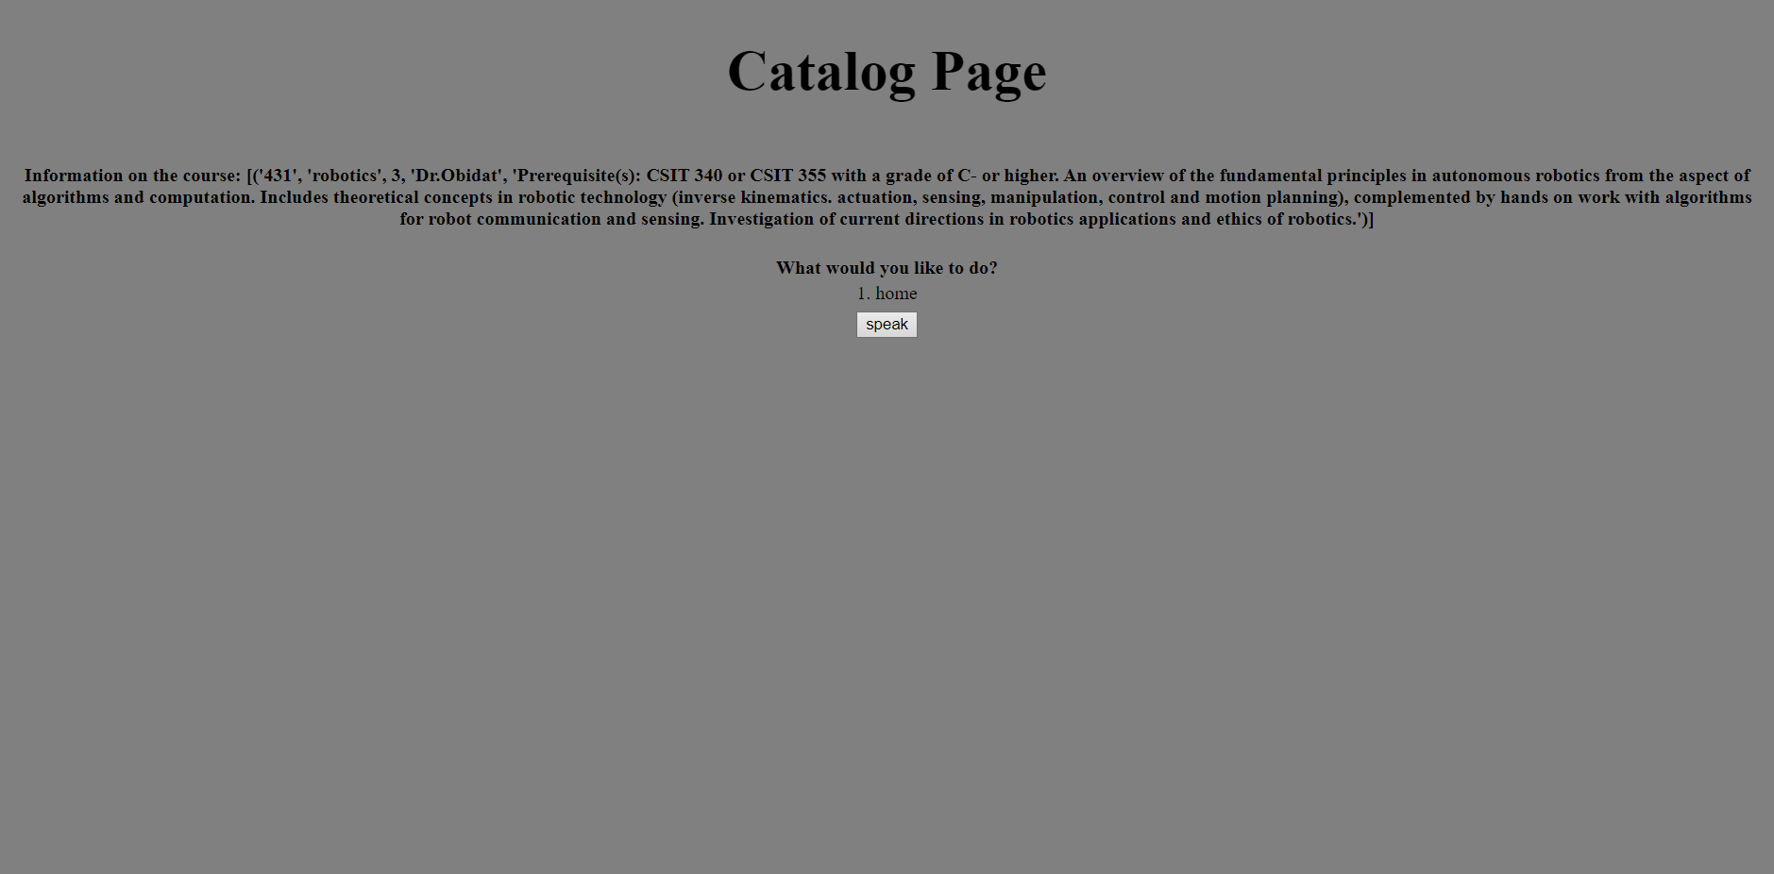

Figure 9 : This is “Course Information” screen for Robotics

5.2.5 From the home page, the user can request academic advisement. The user will click the

“speak” button, and verbally state “academic advisement”. The system will then take the user to the advisement page. It will inquire if the user wants to apply filters, the user may verbally accept or deny by saying “accept” or “deny”. If accept, then the system will ask a series of filters in order to filter the time of day for the class, the total number of credits, any class preferences, and full time or part time. The user may verbally enter their preference for each filter. If they dont want to apply one of the filters the user may state that they want to “skip” that filter. Afterwards the system will output a list of classes the user should take based on the filters and previous taken classes.

If the user said no to the filters. The system will output a list of classes to take based on previously taken courses. Afterwards the user may verbally request to go back to the home page.

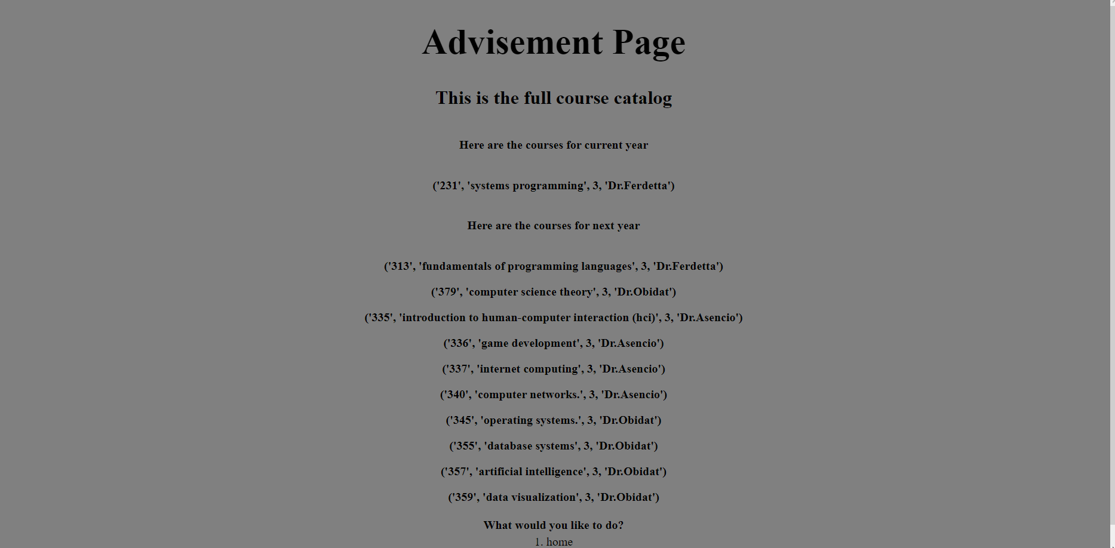

Figure 10 : This is the “Academic Advisement” screen

5.2.6 If the user clicks the “speak” button from the home page and verbally requests to “Log

off” the system will end the session and log the user off.

# FAQ

Who can access the system?

Any Montclair State University Computer Science Undergraduate student who is currently studying or about to start studying into their first academic term can access the system provided valid authentication.

# Glossary

* Introduction
* Purpose of the System
* Project Goals
* Purpose of the Current Document
* Navigate the System Modules
  + Login
  + View all available courses
  + Filter courses
  + View course catalog
  + View course information
  + View own GPA
  + View own Transcript
  + What-if GPA
  + Logout
* FAQ